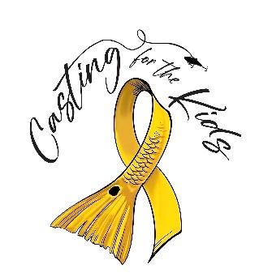

Helping Pediatric Cancer Families Today!!

Tournament Rules 2023 ...Helping Pediatric Cancer Families Today!

● Entry fee is $125 per angler or $400 per vessel up to 4 anglers, $50 ea. additional angler up to 6 max ● Captain’s meeting is MANDATORY for the Captain, but we encourage all team members to be present
at Outboard Club on City Island 1604 Ken Thompson Pkwy, Sarasota, FL 34236. Registrations will be accepted at the meeting from 5:00pm till 7pm. Meeting will start promptly at 6:30pm.
● Fishing hours : Friday Sept 29th, after Captain’s meeting, thru 3:00 pm on Saturday Sept 30th
● Boats must have all pictures submitted by 3:00 pm on the 24th (no exceptions).
● One team member is required to be back at Spanish Point no later than 4pm to receive meal tickets.
Final leader board will be posted at 4:30pm. All discrepancies must be brought to the attention
of the Check In Master at that time. Checks will be cut at 4:45pm, there will be no changes after that
in the event of a late discrepancy
● Awards will be announced at 5:00pm
● Prizes are located on the registration form
● All fish must be caught by hook, line, rod, and reel and only by members of your fishing team.
● All team members must obey all State of Florida Fishing and Boating Regulations, including size and bag limits
● Check In Master will have final judgement on size readings
● All tournament boats must maintain a 75 yard distance from each other (let's please be respectful) ● Anyone caught cheating will be automatically disqualified and banned from all future “CFTK”
tournaments i● Selected fish:
o *Slam: You are allowed 1 entry per species (snook, redfish, trout and mangrove snapper). Winner will be the total inches caught overall, regardless if all 4 species were submitted. Once you submit a picture of 1 species you cannot submit another picture to upgrade a species.
o Calcutta: Total length of 3 like species (snook, redfish or trout...may enter 1, 2 or all 3) will determine the winner of the 3 separate Calcutta opportunities. *Must be registered for Slam.
o Trash Can Slam: Awarded to the angler that catches the largest Trash Fish in inches -Total length. The species are as follows. Lady Fish, Cat Fish and Crevalle Jack.
● All photo submissions must have the provided tournament ruler clearly identifiable in all submitted pictures along with that year’s token provided to you at the Captains Meeting.
● *In the event of a tie, the winner will be determined by the team that registered and paid first!

Most importantly have fun, stay safe! Thank you for helping us to provide much needed support to Pediatric Cancer Families…

**Please make all checks payable to “Casting For The Kids” a 501c3 organization

